The Best Bad Luck I Ever Had

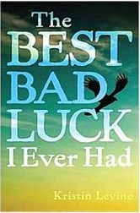
Author: Kristin Levine
Henry Otis Sims is 12 years old, everyone knows him as Dit. He loves to play baseball and even makes his own ball out of string. He lives in a small town in Alabama. He is trying so hard to save all his money so that he can enter the big hunting contest the next summer. Then he makes a new in Emma, the girl who moves in next door. He never expected that their friendship could make things change so much.

Title:
Author:
Replace this typing with a quick summary of a book that peak the student’s interest.

What I like about this book:
You will type in why you liked this book and what you found interesting about it.
Title:
Author:
Replace this typing with a quick summary of a book that peak the student’s interest.

What I like about this book:
You will type in why you liked this book and what you found interesting about it.

