Flora and Ulysses

Author: Kate DiCamillo
The story begins with a vacuum cleaner. And a squirrel. Or, to be more precise, a squirrel who gets sucked into a Ulysses Super Suction wielded by Flora’s neighbor, Mrs. Tickham. After Flora performs CPR, the rescued squirrel, newly named Ulysses, is still hungry, but now he has many thoughts in his head.

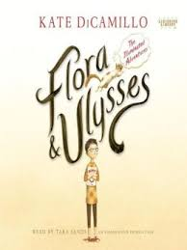
What I like about this book: I really liked how the illustrations complimented the story.

Title:
Author:
Replace this typing with a quick summary of a book that peak the student’s interest.

What I like about this book:
You will type in why you liked this book and what you found interesting about it.

